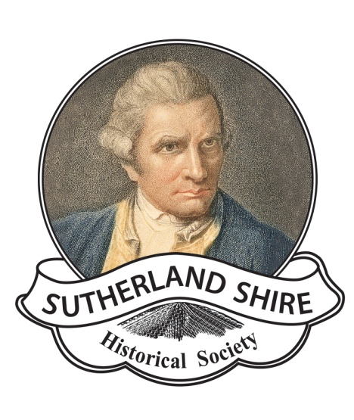
SUTHERLAND SHIRE HISTORICAL SOCIETY INC
88 Venetia Street, Sylvania NSW 2224
shirehistory@gmail.com
www.shirehistory.org

VOLUNTEER POLICY
Introduction
This document aims to explain the elements between SSHS and our volunteers defining reciprocal responsibilities between the museum and the volunteer and clearly setting out the steps to take when a problem arises, duties of the volunteer in furthering the aims of the museum.
What We Offer
- Development of skills such as computer technology, vegetation management, archiving, web development, exhibition management, cataloguing, working with collections.
- Career development , volunteering with a historical organisation is an attractive addition to a resume.
- Working with the public by assisting visitors with research, customer service, taking guided walks and talks.
- Opportunities to do practical work such as exhibition displays, stands and outdoor work.
- Opportunities to volunteer in areas of interest such as local history, research, behind the scenes in a collecting organisation.
- Volunteer roles that offer a variety of alternatives to suit different time commitments.
- The Historical Society provide a great opportunity to volunteer with like minded people. You will be made most welcome and there are opportunities for team work and social interaction with monthly meetings , excursions and bbqs.
- Working with heritage is an important way to preserve and understand a community’s history.

Museum Volunteers
SSHS Museum could not keep its doors open without volunteers who perform many tasks associated with running a museum. Volunteering is the link between local communities through their wide range of skills, expertise, knowledge and dedication to preserving and sharing history. Museum volunteers contribute significantly to the museum’s ongoing existence by maintaining and recording past events, items and objects and being active within the community.
Volunteer Rights
Sutherland Shire Historical Society Inc and Museum acknowledges the following rights for volunteers and will act to uphold these:
- To work in a healthy and safe environment
- To be adequately covered by insurance
- To be given accurate and truthful information about the museum
- To be interviewed and treated in accordance with equal opportunity and anti-discrimination policy
- To be provided with an induction into the museum
- To be provided with sufficient training to perform the designated task
- To have confidential and personal information dealt with in accordance with the principals of the Privacy Act 1988
- To have access to a grievance procedure

Volunteer Obligations to the Museum
Sutherland Shire Historical Society Inc and Museum requires its volunteers to:
- Respect other volunteers and their rights
- Follow museum rules and regulations, including all Workplace Health and Safety guidelines.
- Undertake a commitment to provide visitor service in a friendly, helpful and courteous manner.
- Undertake tasks with professional commitment
- Work with all rostered staff as a team
- Meet the museum’s dress code of good casual wear and appropriate footwear.

Grievance Procedures
- The aggrieved volunteer is encouraged to explore the problem or situation directly with the person(s) involved, clearly outlining what he or she feels should be done to alleviate and remedy the situation.
- If this is not a viable option, discuss the matter directly with the Museum Manager or the Society’s President.
- The parties involved will be asked to comply with the best solution that has been identified by all involved. Information will be treated in the strictest of confidence.

Harassment Statement
Sutherland Shire Historical Society Inc and Museum will not tolerate any form of harassment or bullying in the museum or any venue from which the Society operates.
Volunteers who are found to have acted in such a manner may be required to undertake counselling or may have their voluntary role terminated.

