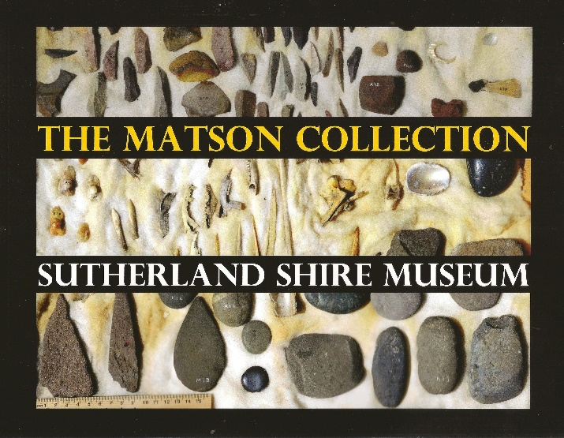
The Matson Collection – Sutherland Shire Museum
by Bruce Howell, 2022
for Sutherland Shire Historical Society

Cost $25.00 + $10.00 postage & handling ($20 for up to 5 books)

Available from Sutherland Shire Historical Society
Email: shirehistory@gmail.com
Post: 88 Venetia Street, Sylvania NSW 2224

This beautifully illustrated publication is a comprehensive catalogue of the Matson collection of Aboriginal artefacts found in Sutherland Shire by Fred Matson (1899-1993), a third generation Shire boat builder. Realising the significance of this unique collection which had been carefully labelled and collated by Matson, Bruce Howell produced the catalogue to ensure a record is kept for posterity. Its detailed descriptions allow viewers to access the collection with more understanding and insight.

TO ORDER A BOOK:
Electronically:
Complete the form below, scan and email it to shirehistory@gmail.com.
Transfer payment of $25 per book (+ Postage & handling) to the Sutherland Shire Historical Society’s IMB account:
Account number: 200798393 BSB: 641-800
Reference: ‘Matson’ and your name
OR
By post:
Post the completed form and your cheque for $25 per book (+ Postage & handling) to:
Sutherland Shire Historical Society,
88 Venetia Street, Sylvania NSW 2224
--------------------------------------------------------------------------------------------------------------
Name: ………………………………………………………………………………………………………..…

Postal Address: ……………………………………………………………………………………………………………

Phone/email contact: ………………………………. No. of books: ………………………………

Payment: $ …………………… Date of electronic transfer (if applicable): ………….………..

