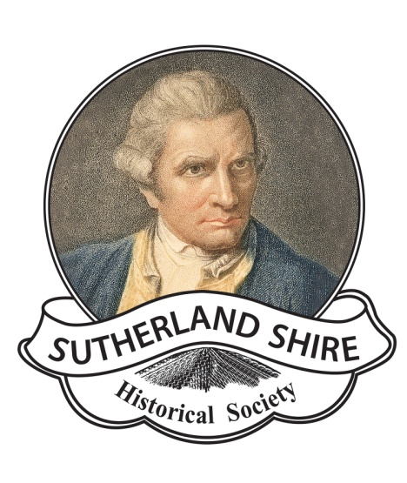
Sutherland Shire Historical Society
ABN: 17083299572

Website: www.shirehistory.org
Email: shirehistory@gmail.com

Museum Object Accession and
Collection Policy

Revised January 2022

Contents

- Statement of purpose
- History of The Sutherland Shire Museum and its Collections
- Collection Aim
- Acquisitions
- Cataloguing and Registering Collection Items
- Documentation
- De-accessioning
- Stocktaking
- Collection Development
10.Collection Care

- Statement of purpose or mission
In broad terms the Sutherland Shire Historical Society, through its various activities is a vehicle through which historical, social, cultural and economic activities of the Sutherland Shire can be gathered, researched,recorded, interpreted and enjoyed in the present and future.
Our vision:
to lead, educate, engage and inspire the community through vibrant and entertaining exhibits, programs, publications and events. Our archives and collection serve as a comprehensive and accessible resource for interested public, researchers, educators and students.

To achieve this we will:

- Provide a welcoming and satisfying social environment whereby the public and volunteer members can express their interests in learning about history through a variety of mediums including discussions, tours, lectures, performances, exhibitions and publications.

- Strategically collect, record and preserve in physical and virtual forms, aspects of our natural, cultural and social history for interpretation by present and future generations.

- Develop a range of informative, educational and socially stimulating programs and events that involve the wider community.

- Target local groups for visits:

School students in the shire, including local secondary school next door. including especially pre-school students ( across the road and one around the corner).

Social groups and community groups, such as Probus, Rotary, U3Aetc.

Retirement homes. (Four nearby).

Parents of school students.

Members of other Historical Societies.

This document is a guiding policy for the development and management of the Sutherland Shire Museum.

- History of the Sutherland Shire Museum and its Collection

From early 2021 the Sutherland Shire Museum will be located on the corner of Venetia Street and Holt Road Sylvania Heights in a small refurbished building originally opened in 1969 as a Baby Health Centre. It is sited on a 700 square metre Crown Land block administered by Sutherland Shire Council. It is adjacent to another larger vacant Crown Land parcel not administered by Sutherland Shire Council and to Sylvania Heights Public School.

The Sutherland Shire Museum is an arm of the Sutherland Shire Historical Society which was established in 1966. From its establishment there has been an affiliation with Sutherland Shire Council.

A museum was established in 1986 when the Sutherland Memorial School of Arts, built in 1922 and dedicated to the men from C Riding who participated in World War I, was renovated by Council. Two rooms were dedicated for use as a regional museum under the jurisdiction of the Sutherland Shire Historical Society. All maintenance and utilities costs were born by Council and no rent was charged.

Changed Council policies led to extensive consultation with Sutherland Shire Council, Sutherland Shire Historical Society, Museums and Galleries of NSW and the museum committee. The museum closed in 2020. Following a period of uncertainty the museum was relocated and it will be reopened in 2021 to a refurbished building and in a new location.

The museum is constrained by space and location limitations and significantly increased financial costs.

As with many regional museums run by historical societies, the financial, regulatory and staffing responsibilities of running a museum have resulted in some Councils assuming the management under Cultural Development Departments with related and complimentary facilities including a cafe, retail, tourism and art galleries (note: Bathurst, Orange, Lithgow, Katoomba). The Sutherland Shire Historical Society ultimately sees this model established by Council and professionally curated as the most desirable model in order to best preserve the Society’s Collection.

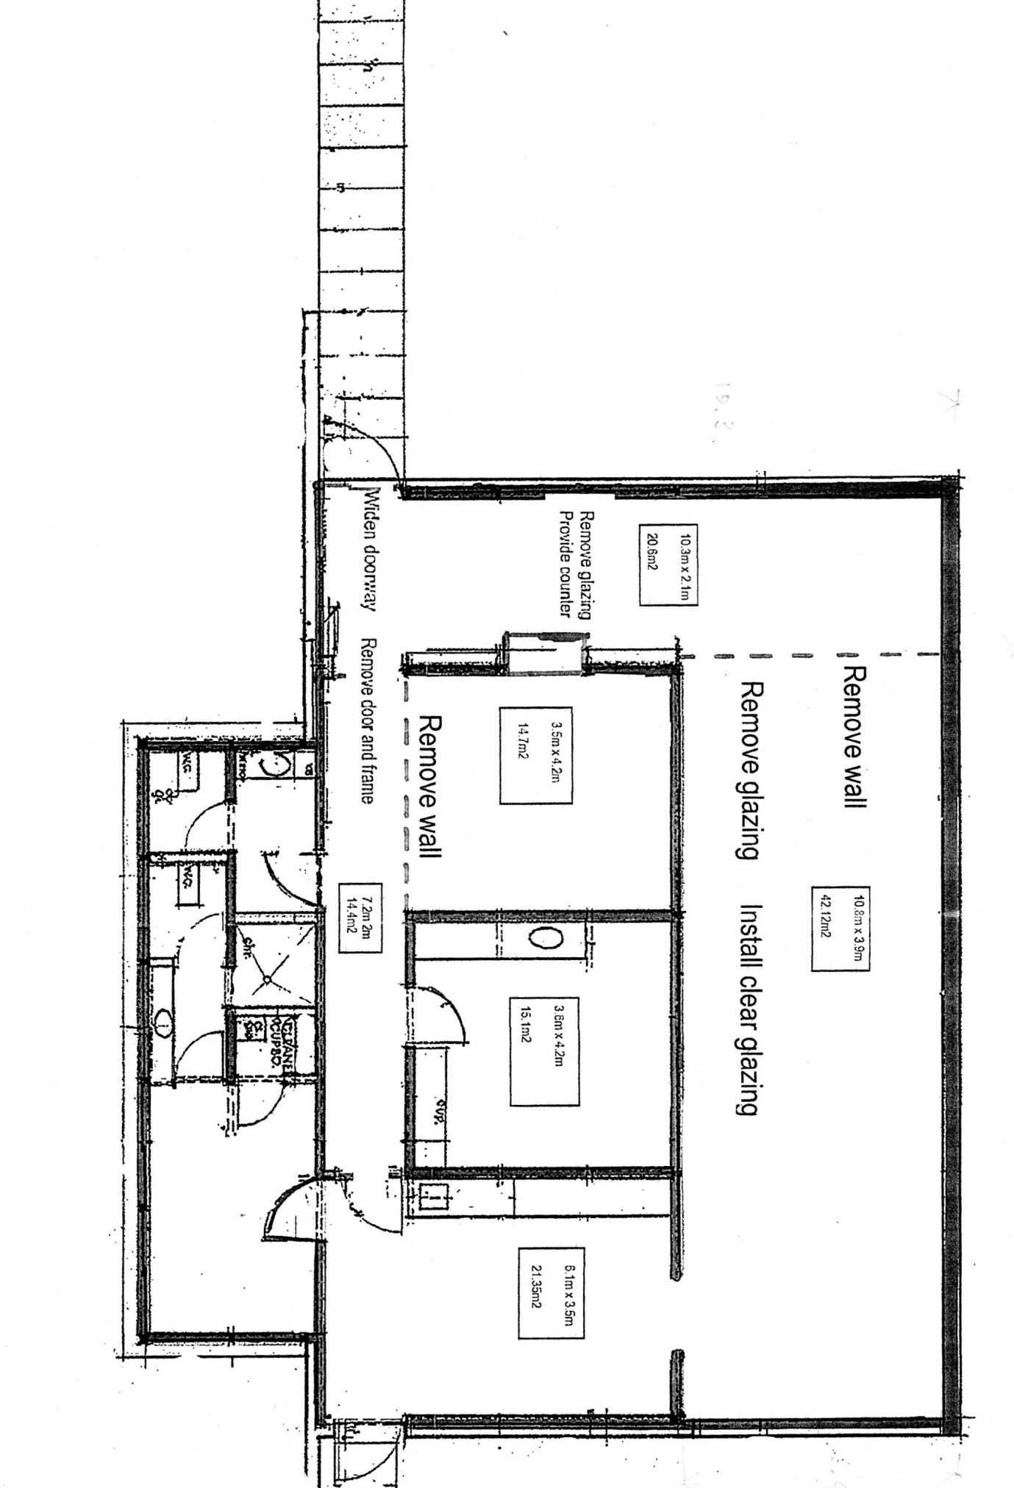
Original Map of 88 Venetia Street, Sylvania.

History of the Collection

The museum has continued to receive donations and actively seek relevant objects , art works, photos , maps , books and other items.

From its inception the Collection has been managed by an elected curator with specific responsibilities and duties, reporting to the Executive Committee of the SSHS.

Historically SSHS has maintained a static survey of the Shire’s history with occasional small focus, temporary displays, always within its own premises.

The Collection has not yet undergone a significant Assessment nor Preservation Needs Assessment (National Library of Australia).

- Collection Aim

The collection aim of the museum is the acquisition and preservation of materials relevant to defined collections supporting the history of the Sutherland Shire. This includes original research, the collection of physical objects, Indigenous and cultural material, audio and film material, books, maps and manuscripts.

Since 1966, space and storage constraints have restricted collecting larger items.

Key themes
A specific focus is items representing :

- indigenous history
- early European history
- pioneering infrastructure
- post war growth.

Display and storage limitations are key considerations in limiting the size of the collection and individual items.

The 2020 Museum has several significant collections relating to key themes including:

- Indigenous physical and cultural artefacts
- Cook and First Fleet (European Imperialism)
- 19th Century settlement – Thomas Holt
- Childhood items
- Photographic records
- Literature (books, maps, documents, posters etc)
- Paintings produced by Shire practitioners
- Social, industrial, economic- pre and post war articles

The Venetia Street museum highlights themes of:

- Aboriginal culture and history
- Exploration – Cook expedition; Bass & Flinders
- Early landholders, especially Thomas Holt and the Holt-Sutherland Company
- Expanding the Shire
- Farming
- Commerce & industry
- Essential services, including electricity, water, toilets, health
- The coming of Suburbia
- Migrant stories
- Surfing culture
- Science & research
- Murder & Mayhem
- Local government, Sutherland Shire Council
- Environmental disasters – bushfires, beach erosion, sandhills

Collecting Criteria

The Core Collection , the museum will collect items for their core collection if they fit the following criteria:

- The item fits within the museum’s purpose, collection aim and collection themes
- The item is historically significant
- The item has clearly established provenance
- The item is in good condition, not necessarily complete
- The item is stable, safe and can be adequately looked after and stored
- The intending donor has legal title to the item
- The item does not unnecessarily duplicate items already in the collection

Non-Core Collection

In addition to the main, or core collection, the museum will maintain a secondary, or non-core, collection. The non-core collection will consist of items that are duplicates or that lack specific provenance and will be used by the museum as display props or for ‘hands-on’ activities.

Photographs and Printed material.

These will be accessioned, with all photographs and printed material kept in filing cabinets organised by subjects and suburbs.
All books and pamphlets will be accessioned and catalogued by the Dewey Decimal Classification system.

Collecting process
Items will be acquired by the following methods:

- Donation
- Bequest
- Purchase
- Transfer

4.Acquisition
Materials will only be acquired when the Museum can provide appropriate resources and storage to ensure their safety.
No materials should be acquired with conditions or restrictions on the way they might be used or displayed in the future. The Museum does not accept conditional donations.
The Museum collects objects that are relevant and have provenance to the Sutherland Shire or to people closely associated with the area at key periods.

Acquisition Procedure

The first point of contact is the Museum Manager who is appointed annually at the AGM.
The Manager will appoint a Museum Committee which includes an Archivist to ensure record keeping.
The donor will be required to record the history, associations, context and significance of the object by completing an Object Donation Inquiry Form. (see appendix) The Museum Manager will appraise the object against the Collection Criteria for its suitability to the collection. On approval of the proposed donation the donor is required to sign an Object Donation Form that assigns legal ownership of the object to the Museum.
In some exceptional cases, objects may be acquired without provenance related to a Sutherland Shire family, place, person, institution or firm, if the object was typically used in the Shire or if the object elucidates taste or style associated with, or unique to the Shire.
Objects without provenance in rare circumstances, will only be accepted where they assist in the interpretation of the Shire’s history, via one of the identified criteria and/or have an educational role.

The primary assessment criteria are:
• historic, aesthetic, scientific, social or spiritual significance
• condition, intactness, integrity
• provenance
• rarity

In rare circumstances objects may be acquired by purchase where the item has specific relevance or rarity.

5.Cataloguing and Registering Collection Items

Only items to be part of the Core Collection will be listed, accessioned, catalogued, described. Other items to be part of the Non-core Collection will be recorded including photographs for ready reference when planning displays and events.
All items will be catalogued as soon as possible after acquisition.

The Museum Manager will be responsible for ensuring all items acquired are catalogued using an Excel spreadsheet, including accession number, description, cabinet or location of object, donor and date acquired(if known), photograph.

We have a specifically built software program using 5 spreadsheets
- Objects
- Photos
- Books and cds
- Maps
- Artworks

The program has been uploaded onto our computer system and updates automatically as any changes are made. (Refer attachment Accession Register User Guide)

Numbering items.
All items will have an accession number attached in a reversible method without compromising the objects, or tagged so reference can be made to the accessioned register. Fragile items should be boxed , suitably cushioned with a number attached to the box.

Outdoor items and stored items should be tagged with an accession number on a key tag attached to the object.

6.Documentation

Object Files

A file will be kept of all collection items giving the accession number and data on how the item was obtained. These files should not leave the museum. Two backup copies will be kept off site with members of the SSHS museum committee.
Object files should include records of the object’s use in displays etc. conservation treatments, associated technical details, reference materials related to style, history etc.

7.De-accessioning

De-accessioning is the process of de-registering an object from the collection for a clearly stated reason and disposing of it in accordance with approved policies. In the longer term, de-accessions will be minimised through careful, strategic collecting.
Only the Museum Manager, in consultation with the Museum Committee, has the authority to de-accession an item from the collection, presenting a case for the need to dispose of an item.

An item may be de-accessioned from the museum’s collection for the following reasons:

- The item is not relevant to the current Collection Policy of the museum
- The item has deteriorated to the point where it cannot be ‘saved’ and has no use as a prop or teaching item.
- The item lacks historical authenticity
- There is a better or duplicate example available
- The item cannot be stored or looked after properly
- There is an alternative or more appropriate custodian for the item

The procedure for de-accessioning an item is as follows:

- Receive approval from the Museum Committee
  - Offer to return to donor or donor’s heirs
  - Transfer to another museum or like-minded collection
  - Sale. Transparency required if volunteers or Committee express an interest in purchasing items
  - Transfer to the museum’s non-core collection
  - Destruction.

8.Stocktaking

There has never been a stocktake undertaken by the Society to date, however one should occur every five (5) years to compare actual objects with accessioned documents, at this time check condition , deterioration and presence of any vermin.

This should be carried out by the Museum Manager and Committee members.

9.Collection Development

The Society wishes to collect particular objects to fill gaps and better reflect the history of the Shire.

Current priorites are surfing and fishing culture and migrant stories.

The deaccessioning process will continue and the Society will actively seek relevant objects from community agencies, commercial businesses important to the Shire.

10.Collection Care

The Society will endeavour to conserve all objects that come into the Collection, inspect, restore and clean to prevent further deterioration.
If an object lacks integrity or has the capacity to tell a stronger story, elements may be reconsidered. This will be by the approval of Museum Manager and Committee.

- Periodic inspection annually to make sure of condition
- Storage system and conditions. Store objects in best possible way to prevent deterioration.
- Cleaning schedule – consider how often objects should cleaned.
- Pest management , some items are prone pests, should be inspected annually.

Review of collection policy

Review in three years after move to Venetia Street premises.

