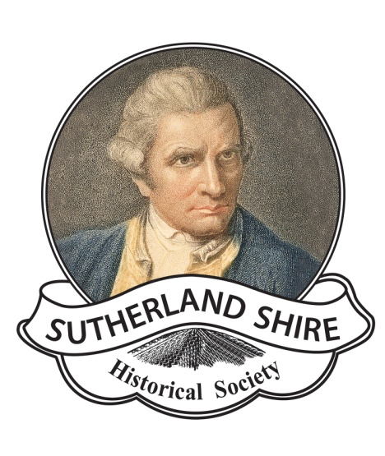
Sutherland Shire Historical Society Inc
ABN: 17083299572
PO Box 389, Sutherland, NSW 1499
Website: www.shirehistory.org
Email: shirehistory@gmail.com

President: Pauline Curby Secretary: John Doherty

ACCEPTANCE OF DONATED MATERIALS
DONOR :
ADDRESS:
PHONE:
EMAIL:
Thank you for donating the item(s) listed below , the Museum Committee will be in contact soon. Please note we do not accept loans.

Donor’s Signature....................................................................................
Receiver’s Signature............................................ Date............................

