Bringing history to the classroom
If you are teaching young children about their past, you will know how useful it is to have objects on hand that bring the past to life for them.
Stored in the Sutherland Shire Museum at 88 Venetia Street, Sylvania is a myriad of objects and photos which show just how people lived in the ‘olden’ days. To name a few, there is a Shoe Last – does anyone know how that was used? We have Chamber pots – no need to explain those. Irons which needed to be heated on the wood fire stove top before pressing clothes, and darning mushrooms for mending socks.
We know kids would find these objects interesting, and more importantly act as a powerful illustration of how changing technology has changed lifestyles.
The Sutherland Shire Historical Society, which runs the Museum, would love to share this wealth of material with teachers. While we welcome school visits to the Museum, we have also put together ‘Museum boxes’ which teachers can borrow and take to the classroom. What’s more! We can make up the boxes to order, depending on your topic.
Below is an example of one Museum Box we have prepared for primary school classes. If you are interested to learn more contact us at shirehistory@gmail.com .
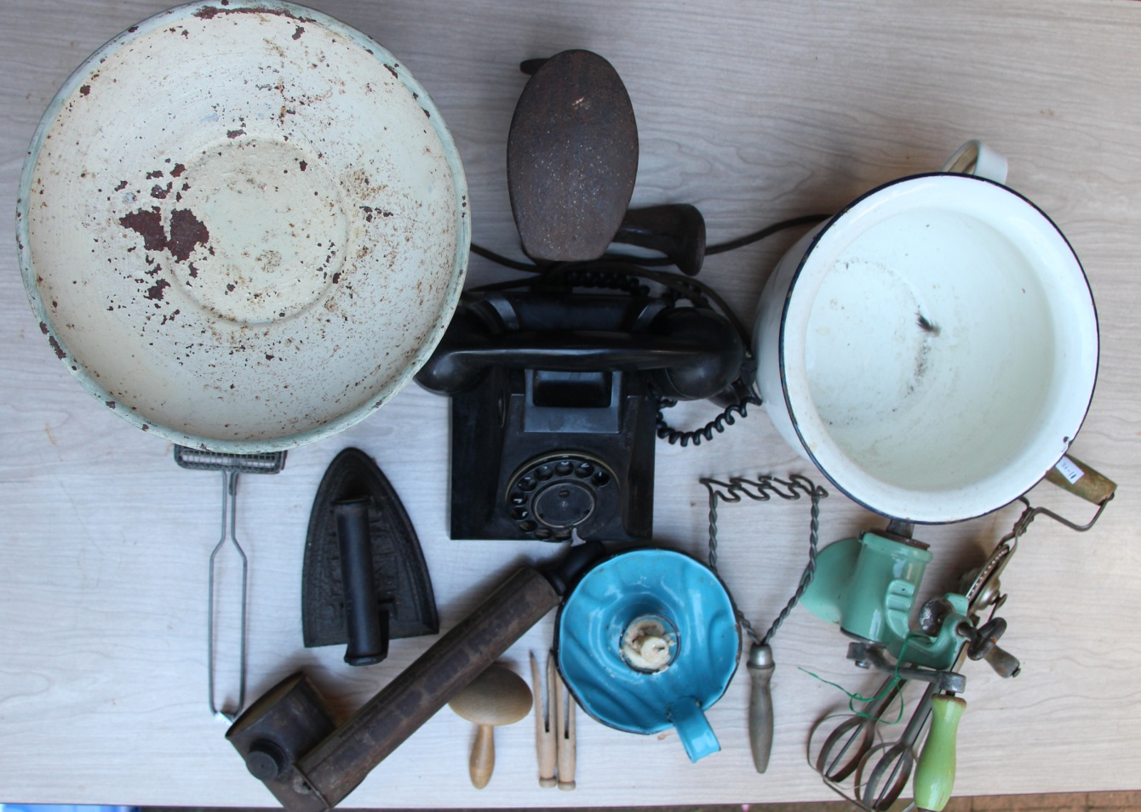
Contents of Museum Box
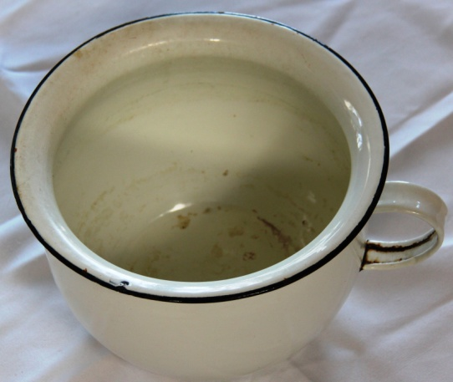 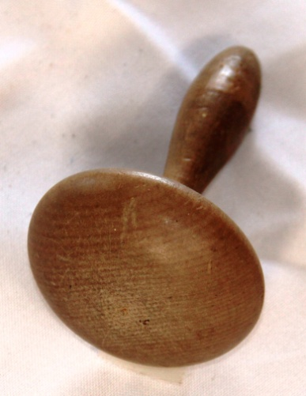 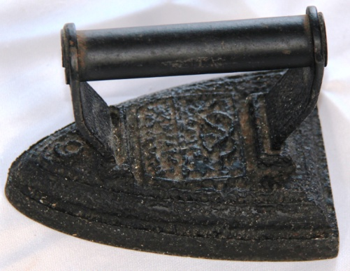 Chamber pot stored under the bed Darning mushroom for Iron – heated on wood fire stovetop
mending socks
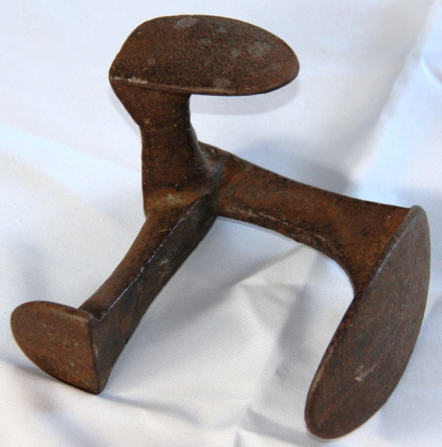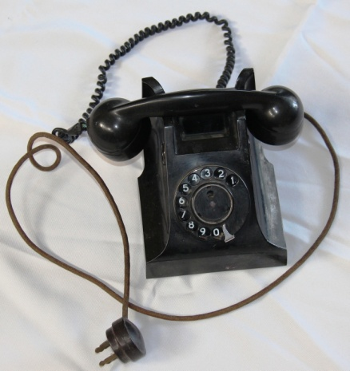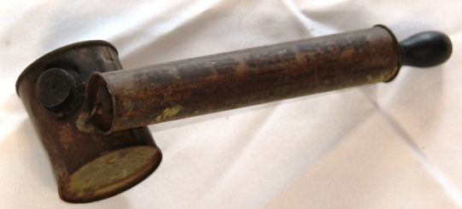
Shoe Last for mending shoes. It Dial telephone Fly sprayer
supports shoe soles and heels as
you hammer in nails
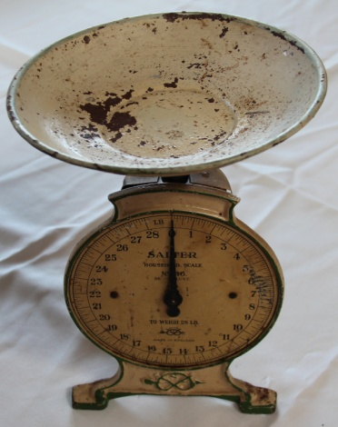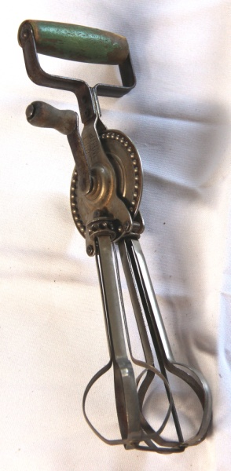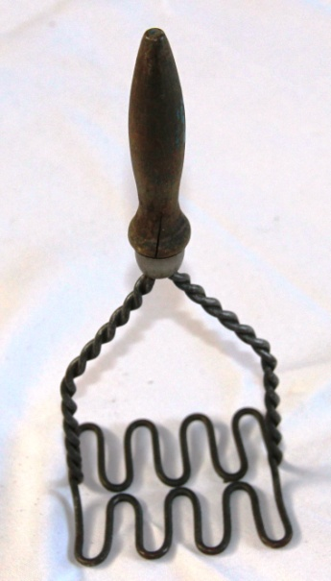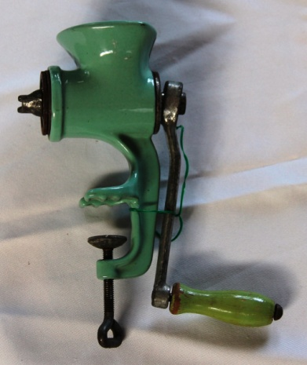
Imperial kitchen scales Egg beater Potato masher Manual meat mincer

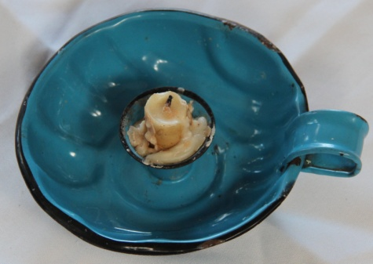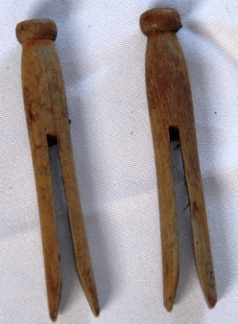
Candle in saucer 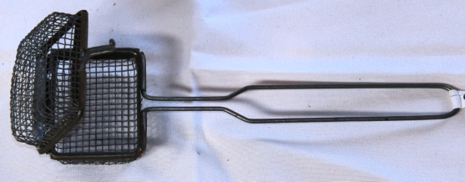 Wooden dolly pegs Soap holder for dish washing

